Exercises on Loops

Programming Fundamentals 1 & 2

Mairead Meagher, Siobhan Roche

- Write a method (exer1() ) to print numbers from 1 to 10, one number per line.
- Write a method (exer2()) to print numbers from 15 to 20 inclusive, one number per line.
- Write a method (exer3()) to print numbers backwards from 10 to 1 inclusive, one number per line.
- Write a method (exer4()) to print numbers backwards from 20 to 15 inclusive, one number per line.
- Write a method (exer5()) to sum the numbers from 1 to 10 inclusive. You should print the sum to the console. (sum is 55)

- Write methods to print the following (name the methods exer6_1(), etc) : 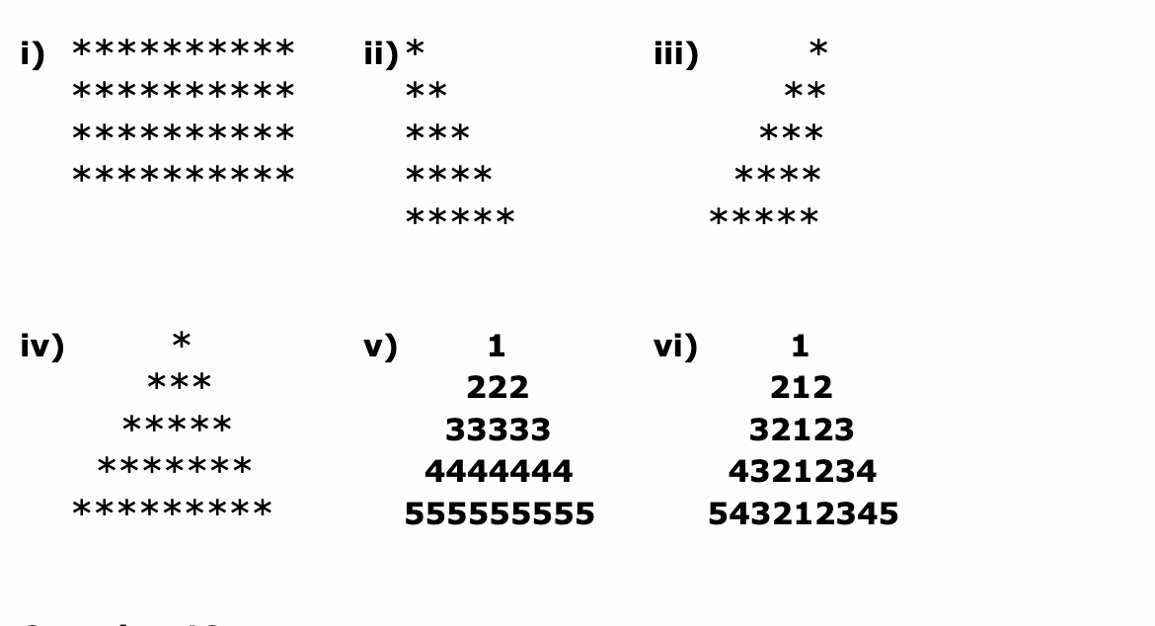

- Write a method exer7(int numRows, int numCols) which prints a rectangle of ‘*’s with numRows lines and numCols asterisks across in each line. So a call of exer7(4, 10) would display the rectangle as in exercise 6.1 above

